**Practical – 9**

**Aim: -** Using of Netstat and its option

The netstat command is a networking tool used for troubleshooting and configuration that can also serve as monitoring tool for connections over the network both incoming and outgoing connections, routing tables, port listening and usage statics are common use for this command.

It is used to display current network connections and port activity on the computer.

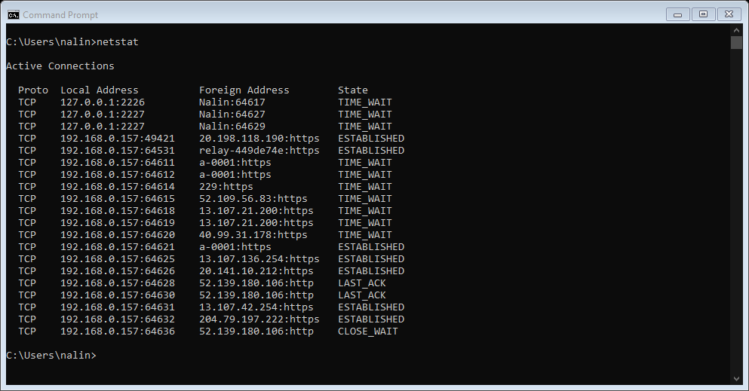

* **TCP** is a protocol.
* **Local IP address** of the computer along with the port no. used with that particular network.

**Foreign address: -** the IP address and the port no. of the remote computer to which the socket is connected. The names that corresponds to the IP address and the port are shown unless the –n parameter is specified. If the port is not yet established the port no. is shown as an *.

**Netstat –n :-** netstat can be combine with sub commands or switches to alter the output netstat –n will show only numbers not the name.

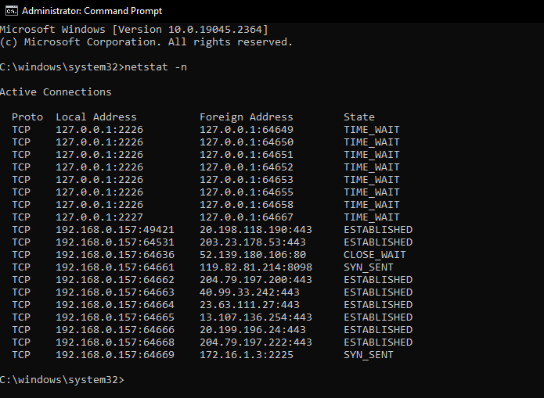

If we do a netstat with a –n switch the output is very fast in fact its instant this is because it does not use DNS to resolve numbers to names. It only shows numbers instead of showing the names of the computer. It only shows their IP address and same they goes with ports it only shows the port no. and not the port names.

**Netstat –a :-** It display active connections and which TCP and UDP ports are listening for the connections.

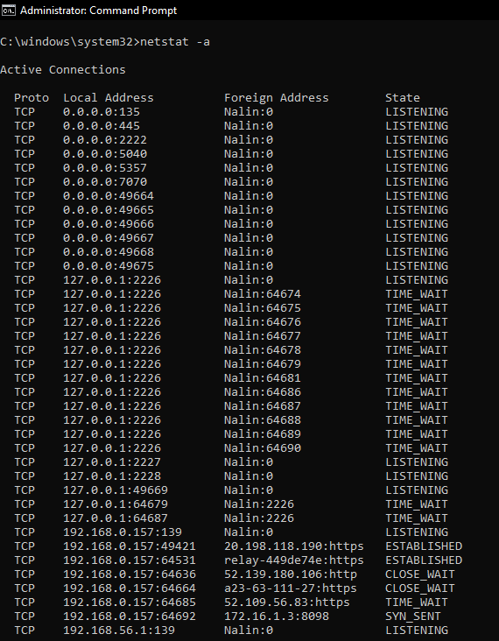 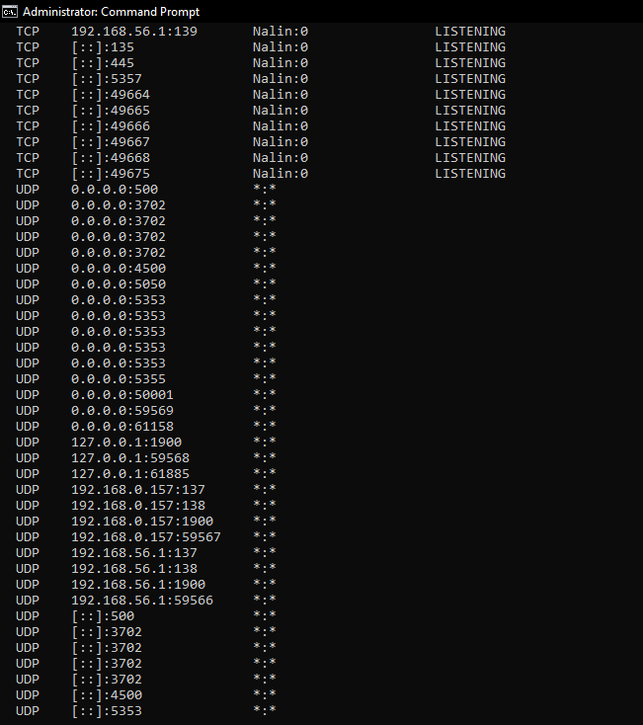

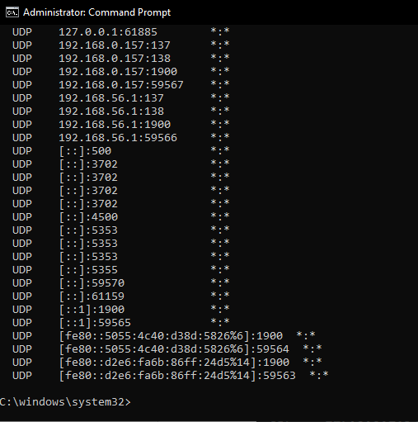

It shows all TCP and UDP ports on the top we see TCP and UDP ports on the bottom . the IP address of all zeros is over computer and the reason while it zero because it means that the port is not listening on a specific IP address. It listening all available IP addresses on all network interface.

**Netstat –b :-** it display which program is used to make the connection.

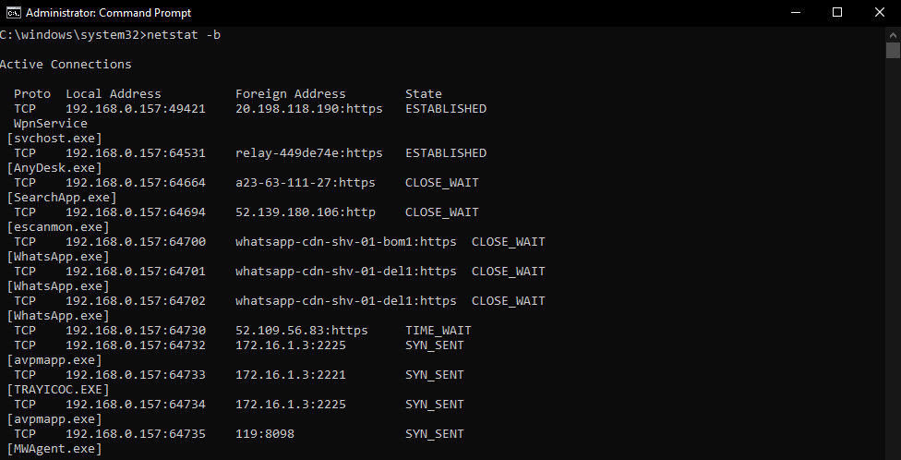

**Netstat –f :-** It display fully qualified domain name in the foreign address column.

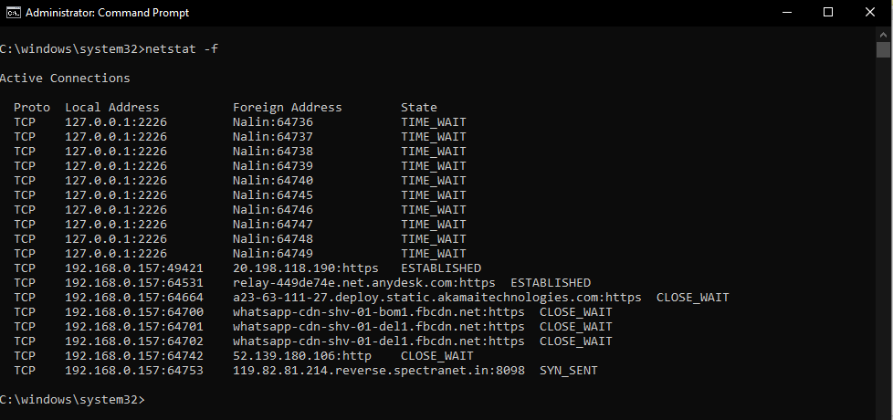

**Netstat –bf :-** It shows the details of both the netstat –b and netstat –f.

